EXPERIMENT NO. 3

EXPERIMENTAL STUDY OF

THE FLOW PAST A CIRCULAR CYLINDER

Submitted by:

YOUR NAME HERE

AEROSPACE AND OCEAN ENGINEERING DEPARTMENT

VIRGINIA POLYTECHNIC INSTITUTE AND STATE UNIVERSITY

BLACKSBURG, VIRGINIA

5 APRIL 2020

EXPERIMENT PERFORMED 22 MARCH 2020

LAB TEACHING ASSISTANT: YOUR TA NAME HERE

|  |  |
| --- | --- |
| Honor Pledge: | |
| By electronically submitting this report I pledge that I have neither given nor received unauthorized assistance on this assignment. | |
| _____________________ | _____________________ |
| Student Number | Date |

Preparation of Papers for AIAA Technical Conferences

First A. Author[1]

*Business or Academic Affiliation’s Full Name 1, City, State, Zip Code, Country*

These instructions give you guidelines for preparing lab reports for AOE 3054 adapted from the AIAA conference paper template and guidelines (available at: [https://www.aiaa.org/docs/default-source/uploadedfiles/aiaa-forums-shared-universal-content/preparation-of-papers-for-technical-conferences.docx?sfvrsn=e9a97512_10).](https://www.aiaa.org/docs/default-source/uploadedfiles/aiaa-forums-shared-universal-content/preparation-of-papers-for-technical-conferences.docx?sfvrsn=e9a97512_10).%20) Note that if you would like to use LaTeX, you may download the AIAA template directly at: <https://www.overleaf.com/latex/templates/latex-template-for-the-preparation-of-papers-for-aiaa-technical-conferences/rsssbwthkptn#.WbgUXMiGNPZ>

This document is to provide you with a format template to use for your report and assist you with the formatting of the chapter, sections, and sub-sections of your document.

The title and structure of each section is to provide guidance material only. While your report should feature the same chapter titles as discussed in class, you should not copy the section titles of this template in your report.

The footnote on the first page should list the name, and student status (undergraduate student) for the author.

1. **Nomenclature (not required for AOE3054, but can be included)**

*A* = amplitude of oscillation

*a* = cylinder diameter

*Cp*= pressure coefficient

*Cx* = force coefficient in the *x* direction

*Cy* = force coefficient in the *y* direction

c = chord

d*t* = time step

*Fx* = *X* component of the resultant pressure force acting on the vehicle

*Fy* = *Y* component of the resultant pressure force acting on the vehicle

*f, g* = generic functions

*h* = height

*i* = time index during navigation

*j* = waypoint index

*K* = trailing-edge (TE) nondimensional angular deflection rate

T

# Introduction

HIS section of your report will describe the objectives of your experiment. These objectives should reflect how a students particular investigation turned out, and what could actually be determined from that experiment (no points for recycling lab manual objectives). Make your writing obvious. Strong goals are those that are specific, and imply some useful gain in knowledge to the reader. Weak goals tend to be general, and therefore not much use to anyone:

* To make flow visualizations of a Clark Y airfoil
* To study the Clark Y airfoil flow
* To gain experience of the oil-flow visualization technique
* To analyze and plot flow visualizations
* To complete experiment 2

This section should feature a summary of how aims were achieved and must include mention of measurements made or procedures carried out and how they relate to aims. The purpose of this is to give the reader a good idea of what to expect in the rest of the report. A few sentences are enough. Mention techniques and approach in summary form only, specifics belong in section 2

Background to technical area of experiment and/or techniques used should be provided. The purpose of the background is to give context to your objectives. It should discuss things that are known in general and not be a specific description of what you did. Draw on the course manual (and external references), past courses/books, online classes for material.

## Equations, Numbers, Symbols, and Abbreviations

In the introduction, you will need to provide some technical background to describe your objectives and methods. For that purpose, you will need to introduce several equations. Equations are centered and numbered consecutively, with equation numbers in parentheses flush right, as in Eq. (1). Insert a blank line on either side of the equation. First use the equation editor to create the equation. If you are using Microsoft Word, use either the Microsoft Equation Editor or the MathType add-on (<http://www.mathtype.com>) for equations in your paper, use the function (Insert>Object>Create New>Microsoft Equation *or* MathType Equation) to insert it into the document. Please note that “Float over text” should *not* be selected. To insert the equation into the document:

Select the “Equation” style from the pull-down formatting menu and hit “tab” once.

Insert the equation, hit “tab” again,

Enter the equation number in parentheses.

A sample equation is included here, formatted using the preceding instructions. To make your equation more compact, you can use the solidus (/), the exp function, or appropriate exponents. Use parentheses to avoid ambiguities in denominators.

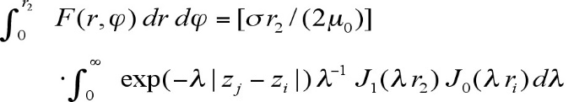 (1)

Be sure that the symbols in your equation are defined before the equation appears, or immediately following. Italicize symbols (*T* might refer to temperature, but T is the unit tesla). Refer to “Eq. (1),” not “(1)” or “equation (1)” except at the beginning of a sentence: “Equation (1) is…” Equations can be labeled other than “Eq.” should they represent inequalities, matrices, or boundary conditions. If what is represented is really more than one equation, the abbreviation “Eqs.” can be used.

Define abbreviations and acronyms the first time they are used in the text, even after they have already been defined in the abstract. Very common abbreviations such as AIAA, SI, ac, and dc do not have to be defined. Abbreviations that incorporate periods should not have spaces: write “P.R.,” not “P. R.” Delete periods between initials if the abbreviation has three or more initials; e.g., U.N. but ESA.

You can complete the intro with an overview of what’s in the rest of the report

# Apparatus and Techniques

In this chapter, you will describe with the appropriate level of detail the instrumentation and procedures used during the experiment. This section should be organized starting with the most general aspect of the work (usually the facility) and go progressively to the more specific (model, instrumentation, miscellaneous items etc…). The title and organization of the sections below does not reflect how you should organize your report but provide you with information on how to format it.

## Photos and Diagrams

You should support your writing with clear and labelled photos and diagrams for every aspect of the instrumentation (facility, sensors, models, data acquisition etc…). Note that you will have figures in Chapter III as well for your data reduction and analysis. The formatting guidelines apply to those as well.

### Photos

Photos should be clear (not blurry) and highlighting specific aspects of the experimental setup. All important aspect of the image should be labelled to focus the reader attention.

### Diagrams

Diagrams are acceptable if drawn professionally using Powerpoint, Photoshop, Paint or any other drawing/CAD software at your disposition. Diagrams should also be labelled appropriately.

### Tables

You may provide tables to summarize testing conditions/locations. The tables should be short and clear. A table of data several pages long does not convey much (if any) information. Table captions are located above the table, are bold and justified, with a period and a single tab (no hyphen or other character) between the table number and table description. There is no required format for the tables themselves, as long as they a clear (and consistent throughout the report). See Table 1 for an example.

Table 1. Variation of the freestream velocity *U∞* and turbulence intensity *URMS* (expressed as percentage of *U∞*) as function of pump speed (in Hertz).

|  |  |  |
| --- | --- | --- |
| Frequency | *U∞* | *URMS* |
| (Hz) | (m/s) | (%*U∞*) |
| 10 | 0.187 | 4.45 |
| 20 | 0.328 | 2.35 |
| 30 | 0.546 | 2.52 |

### Location of tables and figures

**The following discussion is applicable for all tables and figures (i.e. for all chapters of your report**).

You have two options to display your figures: either at the end of the report, or in line with the text. However, you cannot do both ways: **either all your figures are placed at the end of your report, or all of them are in line with the text**.

While it is acceptable to create an appendix at the end of your report to place all your figures, typically, figures are placed directly after the conclusion and before the list of reference and appendices (see the sample report). ALL your figures (photos, diagrams and plots) in your report should be placed there. The figures should be ordered in the sequence they appear in the text (i.e. the first figure you reference in your text should be Figure 1). **If you chose to do so, ALL your figures should be listed at the end of the report.**

It is also acceptable to include the figures in text. **If you chose to do so, ALL your figures should be listed in line with the text only.** To do so, tables and figures should be inserted into text boxes (or frames, if text boxes are not practical) as illustrated here. Text boxes should have no background and no outlines. Both the illustration itself and the caption should be included in the same box. In the electronic template, use the “Figure” style from the pull-down formatting menu to type caption text. Captions are bold and justified, with a period and a single tab (no hyphen or other character) between the figure number and figure description.

Place figure captions below all figures; place table titles above the tables. If your figure has multiple parts, include the labels “a),” “b),” etc. below and to the left of each part, above the figure caption. Please verify that the figures and tables you mention in the text actually exist. *Please do not include captions as part of the figures, and do not put captions in separate text boxes linked to the figures*. When citing a figure in the text, use the abbreviation “Fig.” except at the beginning of a sentence. Do not abbreviate “Table.” Number each different type of illustration (i.e., figures, tables etc…) sequentially with relation to other illustrations of the same type.

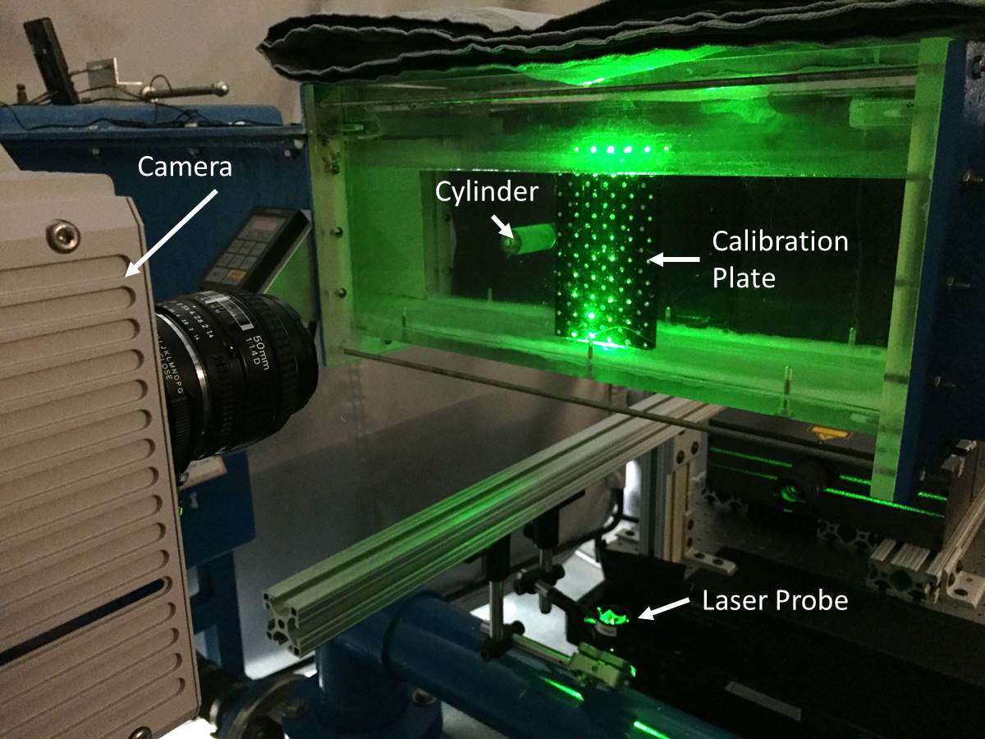

Fig. 1 Camera and laser of the PIV system in the Virginia Tech Water Tunnel. *Figure captions should be bold and justified, with a single tab (no hyphen or other character) between the figure number and the figure description.*

Figure axis labels are often a source of confusion. Use words rather than symbols. As in the example to the right, write the quantity “Magnetization” rather than just “M.” Do not enclose units in parenthesis, but rather separate them from the preceding text by commas. Do not label axes only with units. As in Fig. 1, for example, write “Magnetization, A/m” or “Magnetization, Am−1,” not just “A/m.” Do not label axes with a ratio of quantities and units. For example, write “Temperature, K,” not “Temperature/K.” Typically grid lines will help identify curves and levels more quickly, if you do so **grid lines are required on BOTH axes**. However, it is acceptable to produce a plot without any gridline if you so desire.

Multipliers can be especially confusing. Write “Magnetization, kA/m” or “Magnetization, 103 A/m.” Do not write “Magnetization (A/m) x 1000” because the reader would not then know whether the top axis label in Fig. 1 meant 16000 A/m or 0.016 A/m. Figure labels must be legible, approximately 8-12 point type.

## Instrumentation and Procedures Description

Descriptions of apparatus and instrumentation should be complete (i.e. no missing dimensions, conditions, components that were relevant to the test). When information is missing, it should be properly noted and its possible impact assessed. Limitations and flaws (given the stated goals) as well as attributes of the apparatus and techniques should be adequately noted.

## Primary Uncertainty Estimates

It is important to provide the tools for the reader to evaluate the impact of your instrumentation and procedures on the accuracy of the results. To do so, you will need to provide experimental error estimates - quantitative error estimates (by the student) for readings/measurements from each instrument stated (i.e. uncertainty estimates for primary measurements) and the reasoning behind that stated uncertainty (scale, digital resolution, manufacturer calibration, repeatability etc…). Rather than having a separate section dedicated to primary uncertainties, it is better to introduce the uncertainties when you introduce each instrument and list it there.

If you find a chapter starting at the very bottom of a page, try to edit your text in such a way that it will move the following chapter title to the top of the next page. However, do not leave more than one or two blank lines to achieve this.

# Results and Discussion

## Content

This section is dedicated to the presentation of the results and associated analysis. To do so, you will to present formatted tables and figures (see section II.A.4 for format guidelines and Appendix 1 in the lab manual). The plots and figures will need to be fully described in the text (text states what is plotted, where it is plotted, what's on the axes, what view is shown, what is not shown, why it is shown). Analysis procedures, theoretical comparisons are complete are adequately explained. The results should consist of clear description of data variation, comparison with models/theories.

The discussion then consists in explaining the physical phenomena highlighted by the numerical/graphical results. Results should be sufficiently discussed and concluded (text describes the form of what appears on the plots/figures or in numerical results, what it means/shows/implies physically and how it relates to the stated objectives). Discussion includes where appropriate alternative explanations, deficiencies/limitations of the experiment and acknowledges impact of possible errors/flaws on conclusions.

Results and discussion should not be in separate sections but directly following the presentation of a given set of data with the physical explanation (i.e. the discussion).

The results and discussion chapter should be organized in section that are associated with the stated objectives (one section per objective).

## Derived Results Uncertainties

To complete your reporting, you will need formal uncertainty/error estimates given for basic derived results e.g dynamic flexibility, drag, Reynolds number, bulk modulus, fracture toughness etc. (with explanation of how they were obtained). Table/appendix detailing calculation must be included (note that the uncertainty spreadsheet needs to be formatted properly to be included in the report – all variables must be described, calculations must be detailed etc…). As for the primary uncertainties, avoid having a separate section dedicated to derived uncertainties. Rather, list the derived uncertainties as you introduce your result. Then mention that the process used to compute these uncertainties is described in Appendix.

## General Grammar and Preferred Usage

Use only one space after periods or colons. Hyphenate complex modifiers: “zero-field-cooled magnetization.” Avoid dangling participles, such as, “Using Eq. (1), the potential was calculated.” [It is not clear who or what used Eq. (1).] Write instead “The potential was calculated using Eq. (1),” or “Using Eq. (1), we calculated the potential.”

Use a zero before decimal points: “0.25,” not “.25.” Use “cm2,” not “cc.” Indicate sample dimensions as “0.1 cm x 0.2 cm,” not “0.1 x 0.2 cm2.” The preferred abbreviation for “seconds” is “s,” not “sec.” Do not mix complete spellings and abbreviations of units: use “Wb/m2” or “webers per square meter,” not “webers/m2.” When expressing a range of values, write “7 to 9” or “7-9,” not “7~9.”

A parenthetical statement at the end of a sentence is punctuated outside of the closing parenthesis (like this). (A parenthetical sentence is punctuated within parenthesis.) In American English, periods and commas are placed within quotation marks, like “this period.” Other punctuation is “outside”! Avoid contractions; for example, write “do not” instead of “don’t.” The serial comma is preferred: “A, B, and C” instead of “A, B and C.”

The word “data” is plural, not singular (i.e., “data are,” not “data is”). The subscript for the permeability of vacuum µ0 is zero, not a lowercase letter “o.” The word “micrometer” is preferred over “micron” when spelling out this unit of measure. A graph within a graph is an “inset,” not an “insert.” The word “alternatively” is preferred to the word “alternately” (unless you really mean something that alternates). Use the word “whereas” instead of “while” (unless you are referring to simultaneous events). Do not use the word “essentially” to mean “approximately” or “effectively.”

Be aware of the different meanings of the homophones “affect” (usually a verb) and “effect” (usually a noun), “complement” and “compliment,” “discreet” and “discrete,” “principal” (e.g., “principal investigator”) and “principle” (e.g., “principle of measurement”). Do not confuse “imply” and “infer.”

Prefixes such as “non,” “sub,” “micro,” “multi,” and “"ultra” are not independent words; they should be joined to the words they modify, usually without a hyphen. There is no period after the “et” in the abbreviation “et al*.*” The abbreviation “i.e.,” means “that is,” and the abbreviation “e.g.,” means “for example” (these abbreviations are not italicized). If desired, more detailed style and formatting instructions can be found in the AIAA style guide, *AIAA Style* (available from AIAA upon request).

# Conclusion

The conclusion chapter provides a (stand alone) summary of what was done. It provides enough information about the experimental setup and test conditions to be understood on its own, but details should be kept for Chapters II and III.

The section should continue with a series of short numbered statements of what was learned. These statements should not present new material and must adequately cover the objectives and main points of discussion. That means that all conclusions should have been introduced in the Results and Discussion chapter.

A conclusion might elaborate on the importance of the work or suggest applications and extensions. *Note that the conclusion section is the last section of the paper that should be numbered. The appendix (if present) and references should be listed without numbers.*

# Appendix

You will need at least one appendix to describe the derived uncertainty calculations. You may use the following material (in Section VI.A) as a start to your section as you need to have an explanation to accompany uncertainty calculation tables – see sample report for table format (need to format uncertainty spreadsheet for maximum credit). Be sure to explain what the different variables (a, da, b, db etc…) are in your particular case.

You can have other appendices for other items (data tables etc.) but these need to be explained to.

## Uncertainty Analysis

Uncertainties in measurements were calculated for 20:1 odds. Sources of uncertainty included the accuracy with which the digital manometer could be read, and the resolution of the thermometer and barometer used to measure atmospheric conditions. Specific uncertainties in these primary measurements are given in section 2. To obtain uncertainties in results R derived from these measurements, uncertainties were combined using the root sum square equation,

$δ\left(R\right)=\sqrt{{\left(\frac{∂R}{∂a}δ(a)\right)}^{2}+{\left(\frac{∂R}{∂b}δ(b)\right)}^{2}+{\left(\frac{∂R}{∂c}δ(c)\right)}^{2}+…}$ (2)

where a, b, c… are the measurements on which R depends. Partial derivatives were estimated numerically, the whole calculation being performed using a spreadsheet table. Calculations for the uncertainty in Reynolds number and free stream velocity, are given in tables 4 and 5 below, respectively…

# References

The following are intended to provide examples of the different reference types, as used in the AIAA Style Guide. There are various reference formatting styles (listing them in order they are cited in the text as is done below, or listing in alphabetical order by first author last name). Be sure to be consistent and once you have selected one, ensure that all your references follow that style. You are not required to indicate the type of reference; different types are shown here for illustrative purposes only.

*Periodicals*

1Vatistas, G. H., Lin, S., and Kwok, C. K., “Reverse Flow Radius in Vortex Chambers,” AIAA Journal, Vol. 24, No. 11, 1986, pp. 1872, 1873.

2Dornheim, M. A., “Planetary Flight Surge Faces Budget Realities,” Aviation Week and Space Technology, Vol. 145, No. 24, 9 Dec. 1996, pp. 44-46.

3Terster, W., “NASA Considers Switch to Delta 2,” *Space News*, Vol. 8, No. 2, 13-19 Jan. 1997, pp., 1, 18.

All of the preceding information is required. The journal issue number (“No. 11” in Ref. 1) is preferred, but the month (Nov.) can be substituted if the issue number is not available. Use the complete date for daily and weekly publications. Transactions follow the same style as other journals; if punctuation is necessary, use a colon to separate the transactions title from the journal title.

*Books*

4Peyret, R., and Taylor, T. D., *Computational Methods in Fluid Flow*, 2nd ed., Springer-Verlag, New York, 1983, Chaps. 7, 14.

5Oates, G. C. (ed.), *Aerothermodynamics of Gas Turbine and Rocket Propulsion*, AIAA Education Series, AIAA, New York, 1984, pp. 19, 136.

6Volpe, R., “Techniques for Collision Prevention, Impact Stability, and Force Control by Space Manipulators,” *Teleoperation and Robotics in Space*, edited by S. B. Skaar and C. F. Ruoff, Progress in Astronautics and Aeronautics, AIAA, Washington, DC, 1994, pp. 175-212.

Publisher, place, and date of publication are required for all books. No state or country is required for major cities: New York, London, Moscow, etc. A differentiation must always be made between Cambridge, MA, and Cambridge, England, UK. Note that series titles are in roman type.

*Proceedings*

7Thompson, C. M., “Spacecraft Thermal Control, Design, and Operation,” *AIAA Guidance, Navigation, and Control Conference*, CP849, Vol. 1, AIAA, Washington, DC, 1989, pp. 103-115

8Chi, Y., (ed.), *Fluid Mechanics Proceedings*, SP-255, NASA, 1993.

9Morris, J. D. “Convective Heat Transfer in Radially Rotating Ducts,” *Proceedings of the Annual Heat Transfer Conference*, edited by B. Corbell, Vol. 1, Inst. Of Mechanical Engineering, New York, 1992, pp. 227-234.

*Websites*

10Borgoltz, A., and Devenport W. J., “Experiment 1 – Flow Visualization”, *AOE 3054 online manual*, available at: <http://www.dept.aoe.vt.edu/~aborgolt/aoe3054/manual/expt1/index.html>, last update: 30 Jan. 2015, accessed: 20 Jan. 2016.

1. Insert Job Title, Department Name, and AIAA Member Grade (if any) for first author.